# Short User Guide of SMBVT

1. After clicking on an event in the list at the bottom of the tool interface, the event information is loaded into the right-hand side panel and can be modified.

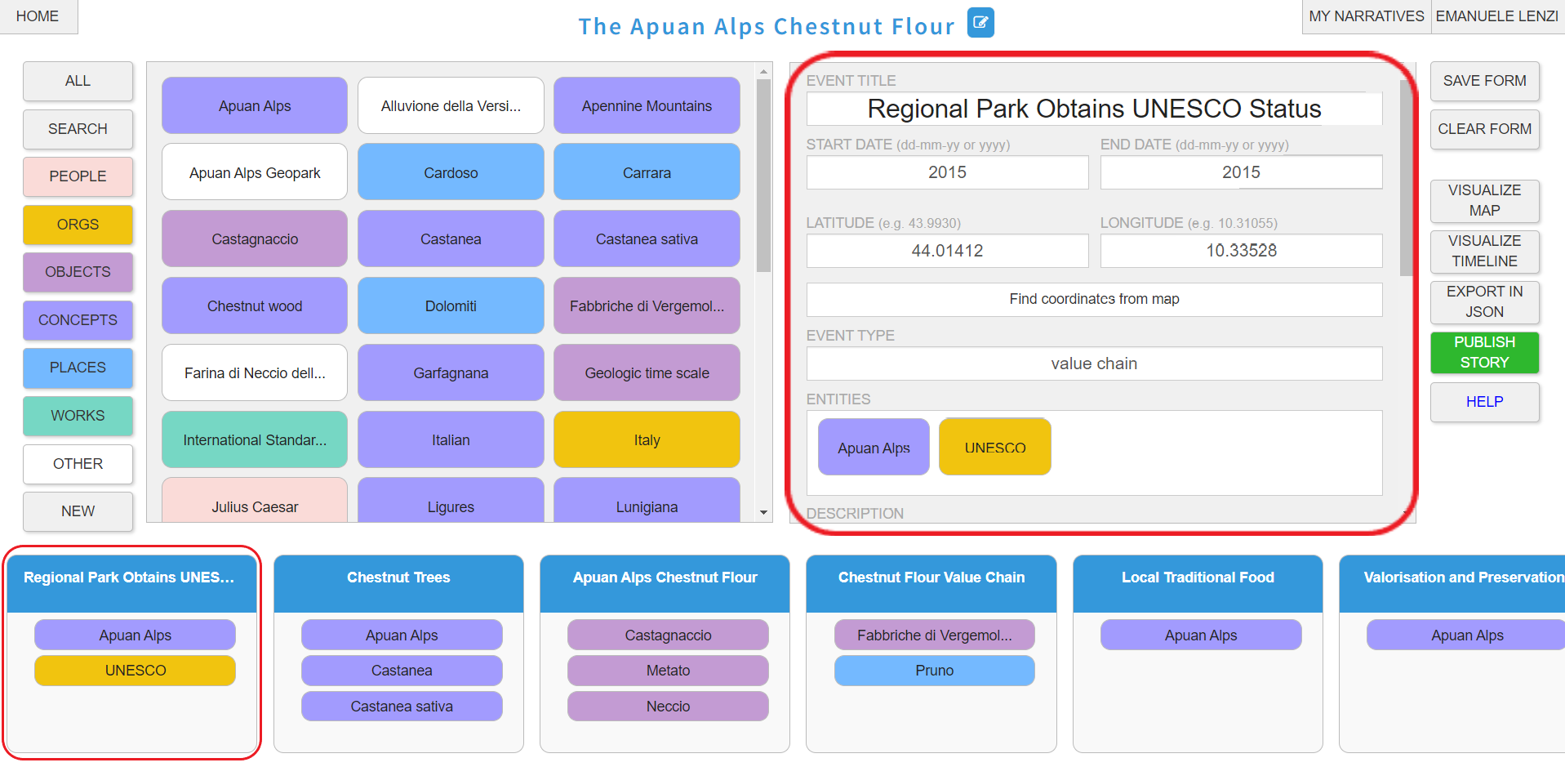

1. Click SAVE FORM to save event modifications.

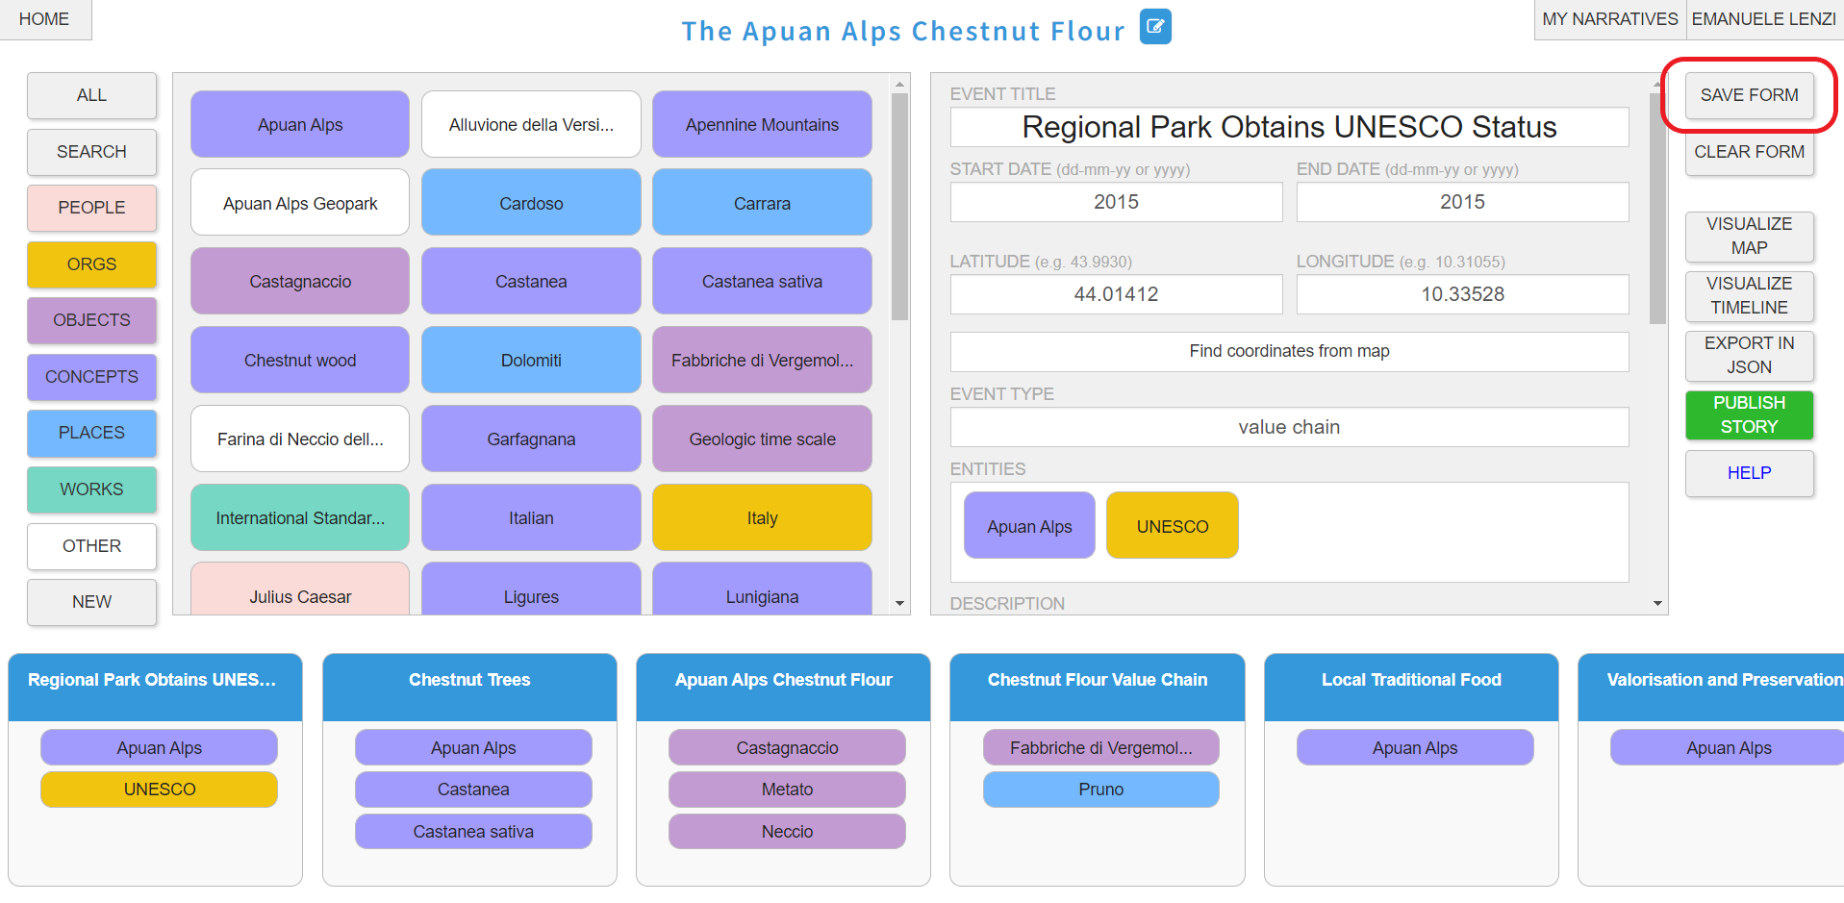

1. Click “Find coordinates from map” button to open a window with a map. Click on a point of the map to find latitude and longitude. Then click “Confirm” button to automatically save the coordinates in corresponding fields of the event interface.

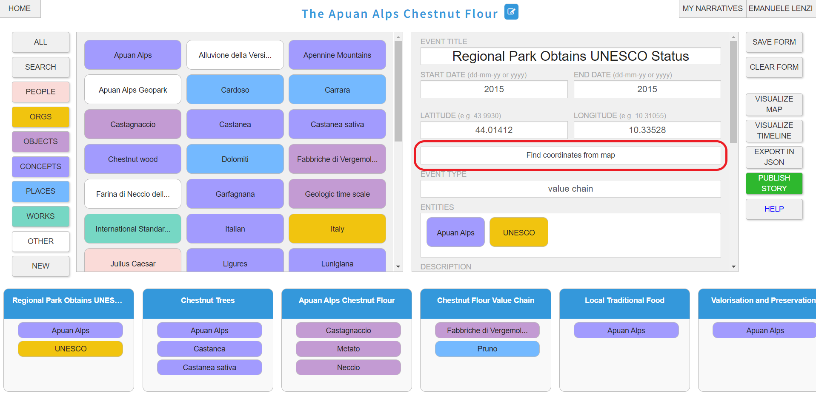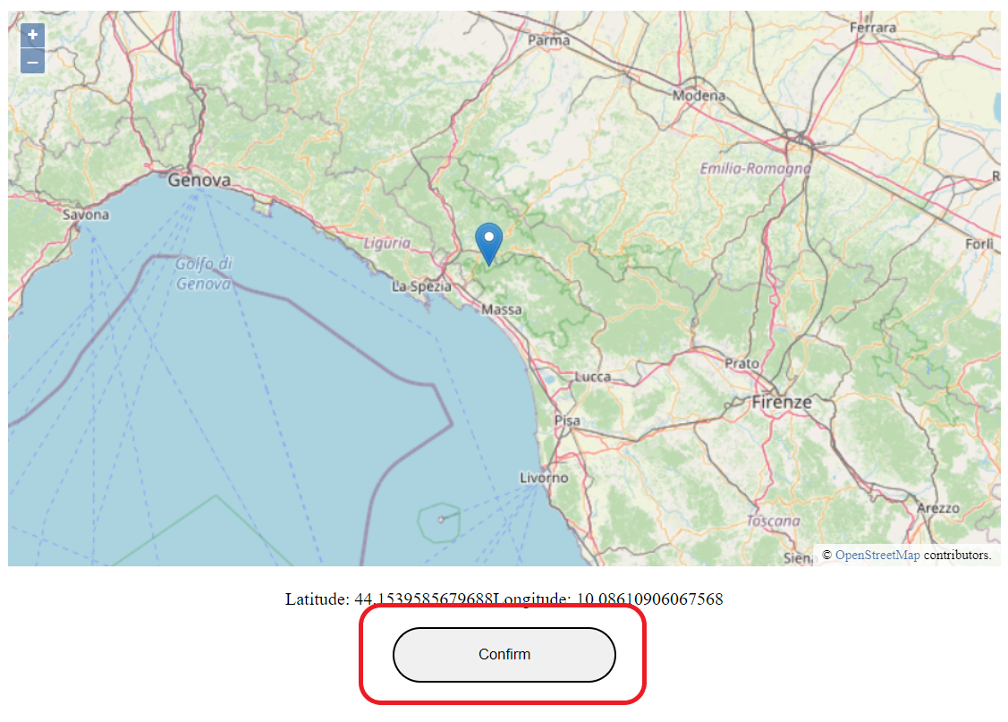

1. Use the ADD MEDIA URL OR UPLOAD IMAGE FROM DISK field to associate an HTTP link of an image or video to the event or to upload a file from the disk. The maximum size of the file must be 2 MB.

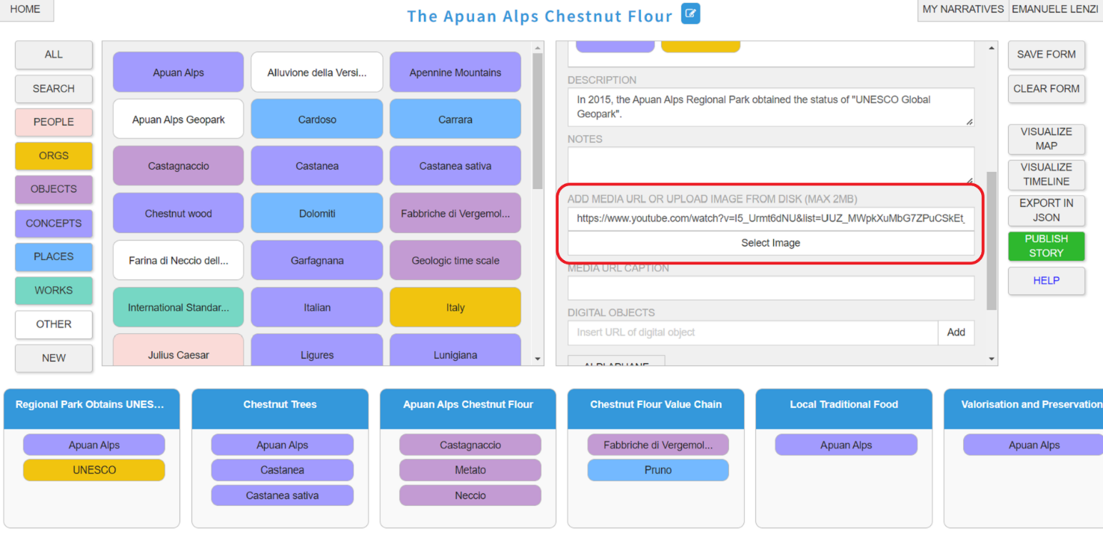

1. Use the DIGITAL OBJECTS text area to associate one or more HTTP links to the event corresponding to digital objects (e.g. web pages, video, public pdf files). Click ADD to make the modification effective.

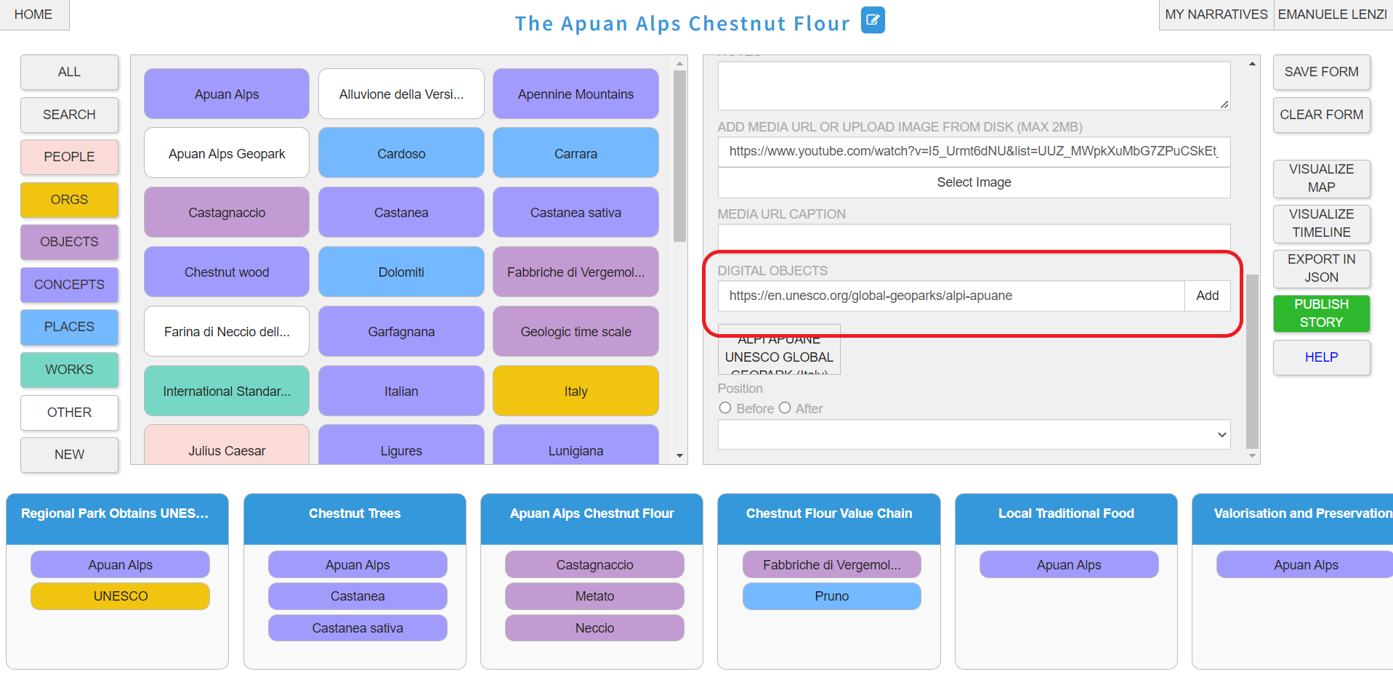

1. Use the BEFORE/AFTER radio buttons to set the event position in the story. This position corresponds to the order in the event list at the bottom of the tool interface.

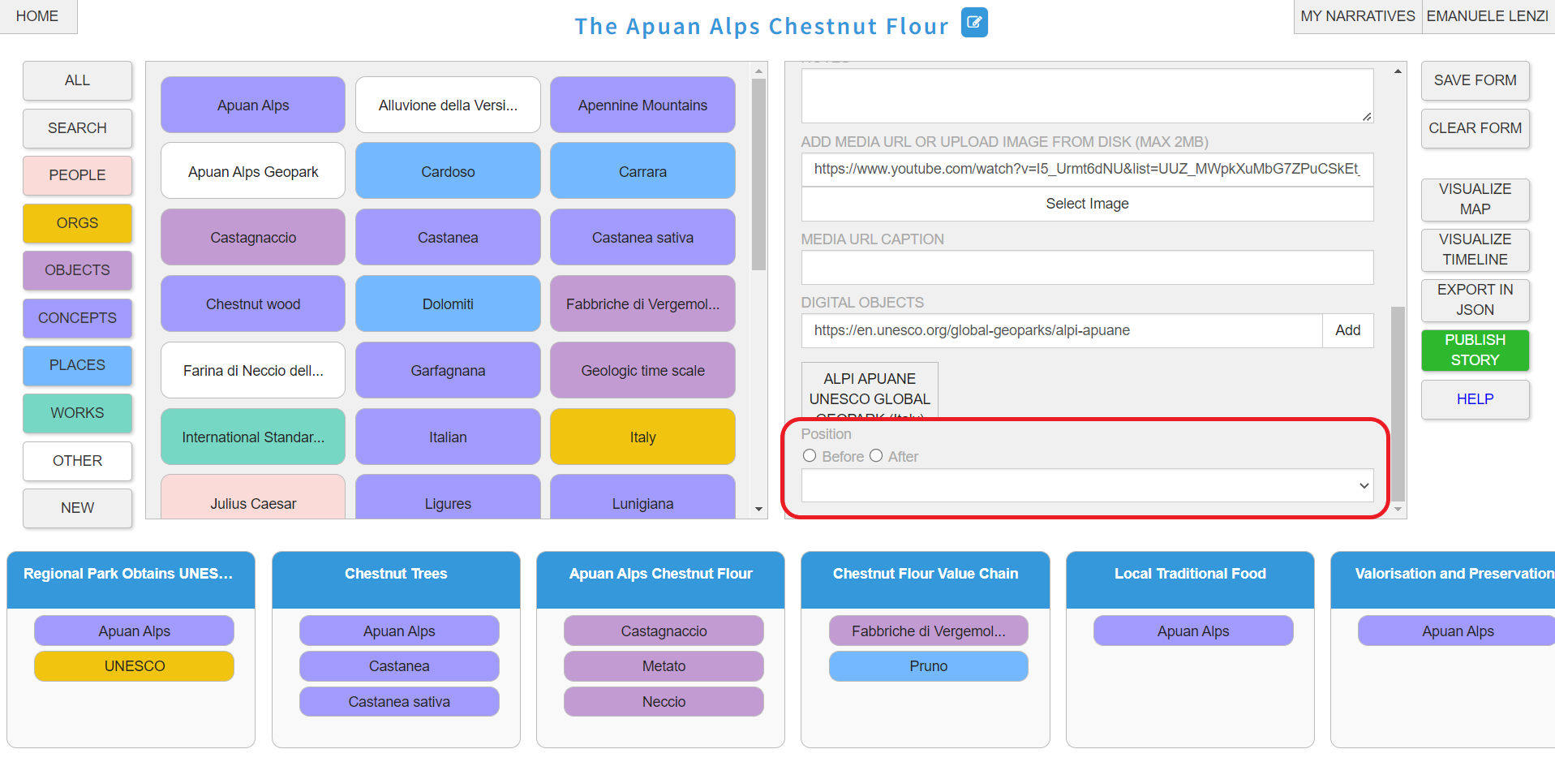

1. After finalising event creation and modification, click the VISUALISE MAP button to get a story map preview.

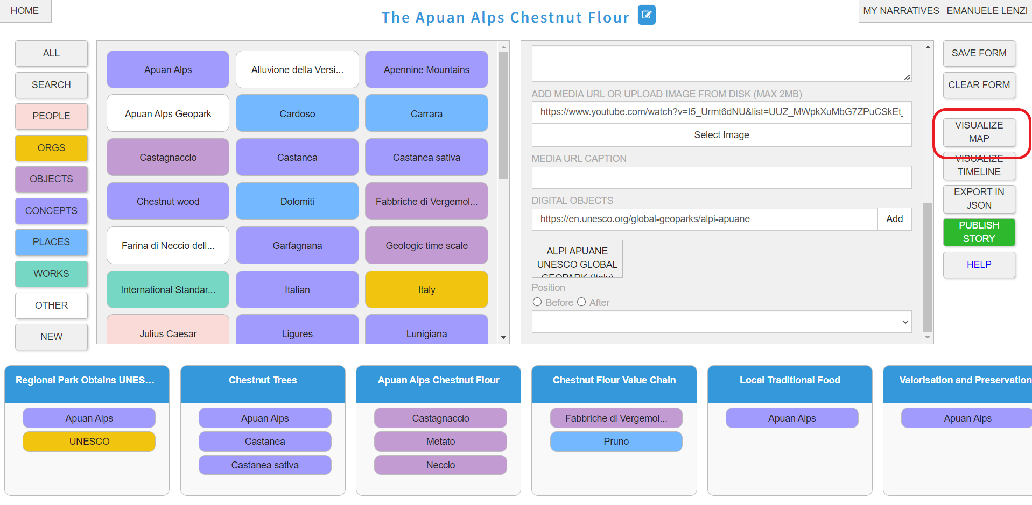

1. If the preview is satisfactory the story can be published to be visualised outside the tool by clicking the PUBLISH green button.

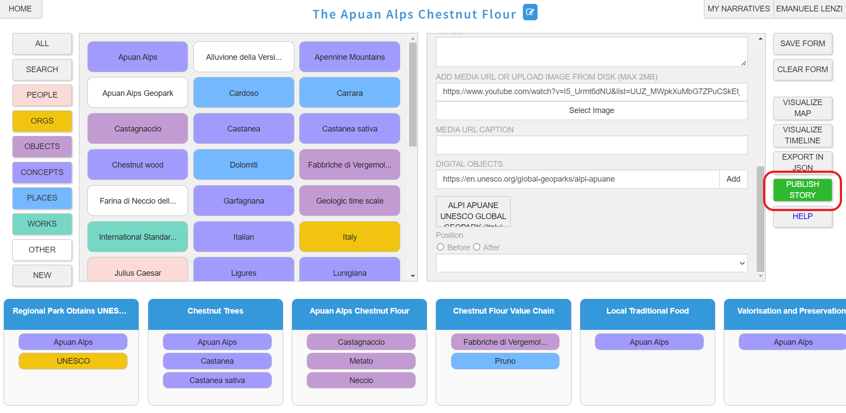

1. After clicking the PUBLISH green button, the tool provides 3 different links: to the story map, to the timeline (if any), and to a search page. Note that, from the story map visualisation link, you can access the timeline visualisation and the search page at any moment.

